As a customer I want to see what products are recommended for the pupil and be able to add the items into my order

I set up Appointments using DateTime.Today This way the dates will always work.  
  
I added an action called Appointments For that takes a date parameter.  That way you can search for appointments for any time in the future.

I have learned that collections are a useful and more powerful way of storing products instead of lists and I have come across the issues of many to many relationships when mapping to the database.

Below are the new objects and methods and the user interface:

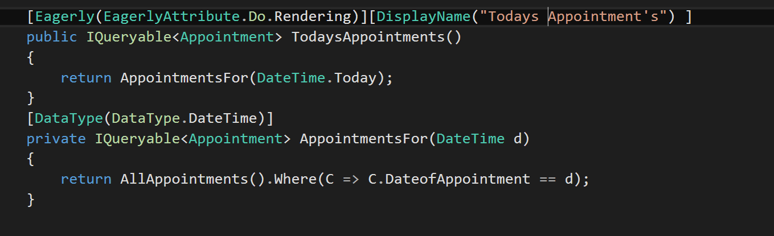

 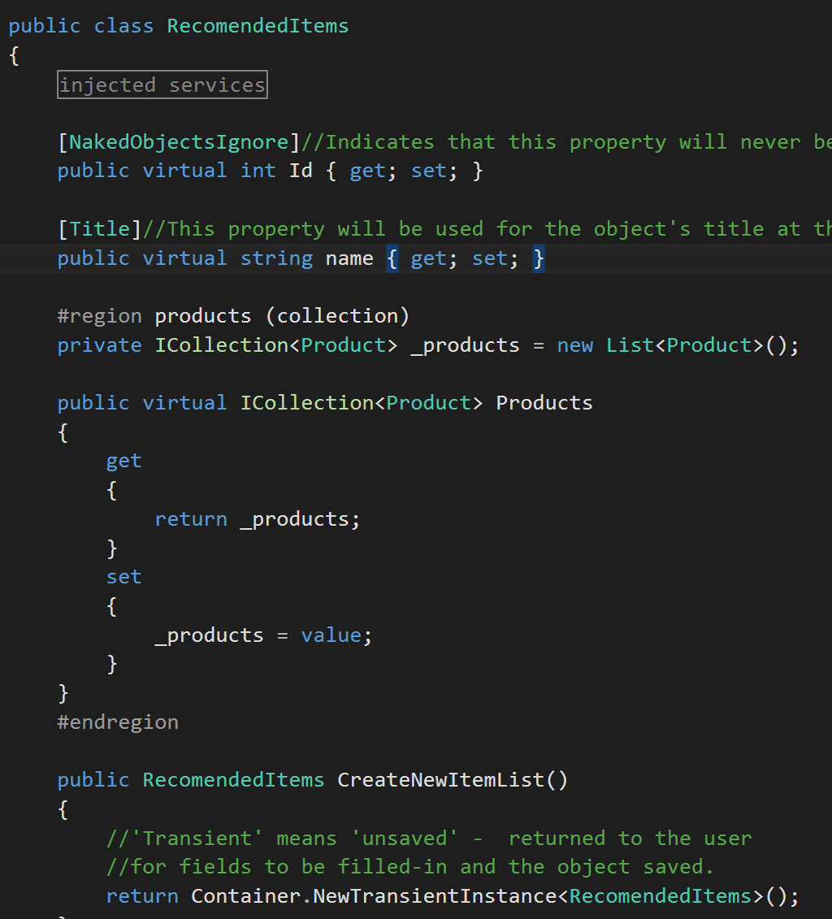

I also met the future objective of last weeks iteration of make the system more user friendly by integrating the orderline so the user doesn’t have to use it manually. I added this method and removed orderline from the user interface.

